**User testing results briefing**

Ilkka’s comments:

Thank you! Looks interesting!

Is there some way for me to query data that has been inserted? Do you have your own instance of OSM server?

About address: Do you have plans to pre fill fields based on reverse geocoded address? It would simplify process a lot.

In a meanwhile, I have implemented to BlindSquare system that can announce these kind of things. It is currently in test use in University of Iowa. For them I created Google Spreadsheet with information they can edit. BlindSquare can read information via this kind of url:

<https://docs.google.com/spreadsheet/pub?key=0AnyeWiOUj2KhdHBIdGJwWGQtUmhTMzRaa2lXVUN2M3c&output=csv>

...you can see same data in html table with this:

<https://docs.google.com/spreadsheet/pub?key=0AnyeWiOUj2KhdHBIdGJwWGQtUmhTMzRaa2lXVUN2M3c&output=html>

Here you can see, that they are adding entrances, strairs (with information about them going up or down), obstacles, info and art. For most of them it is valuable to know also compass heading, so it will be announced only when you are coming from certain direction. For entrances this is not so important, but for example for stairs up/down we need to know from which direction it is announced. Maybe you can get some ideas from this data to your system.

But good news is, that I already have in BlindSquare possibility to use this kind of data. I only need some service where data can be read.

Tuukka’s comments:

Great progress! I filled in the survey and filed some issues in Github. A few points regarding the survey:  
  
1. OSM experience may vary from "never heard" through "used it", "contributed" to "familiar with all the relevant tags".  
  
2. Device form factor would allow you to differentiate between e.g.  Safari on iPhone/iPod Touch, iPad and MacBook, or Firefox/Chrome on different Linux devices.  
  
3. Questions 6-9: "Other (please specify)" is not clear here, as opposed to something like "Comments".

Survey responses:

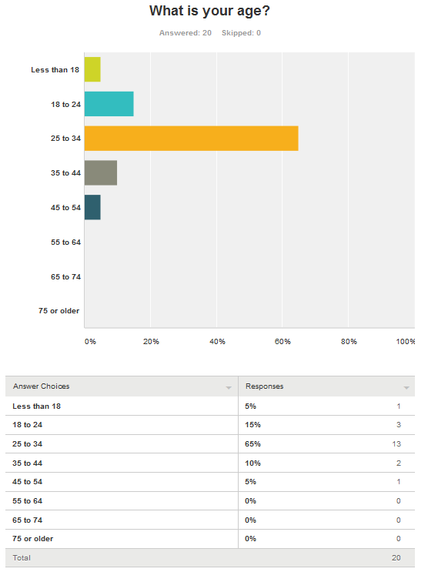

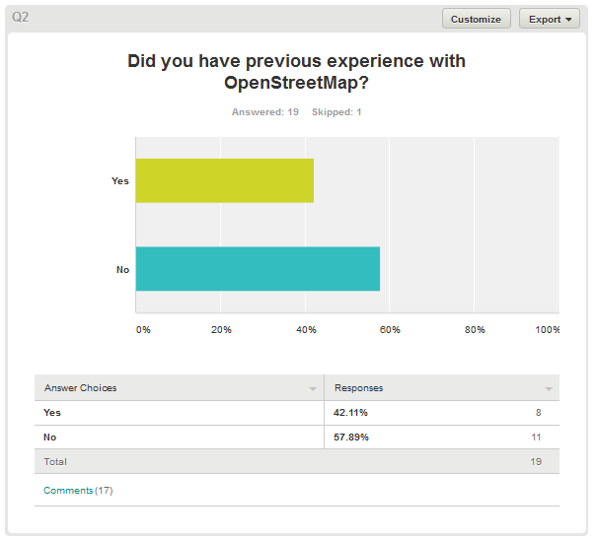

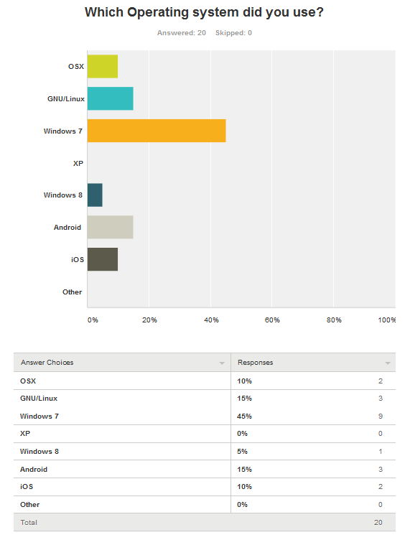

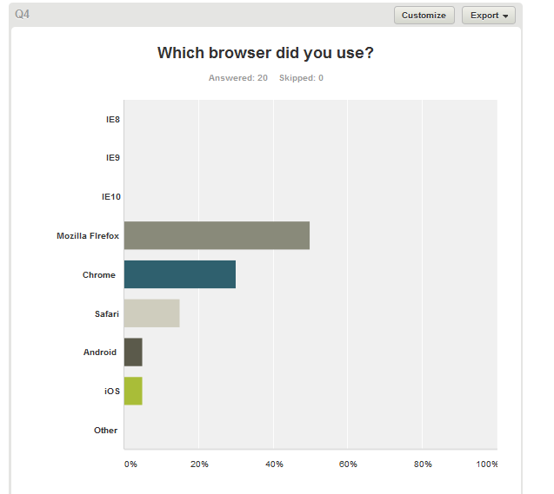

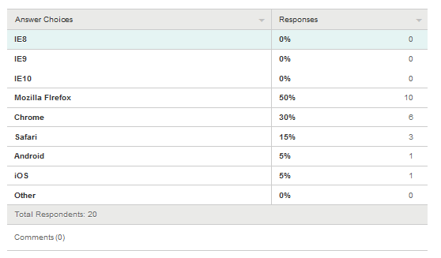

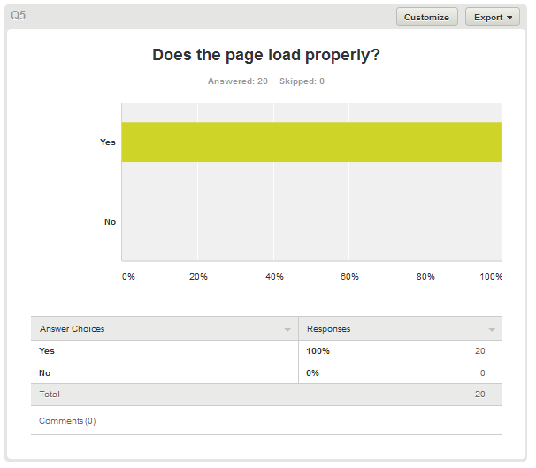

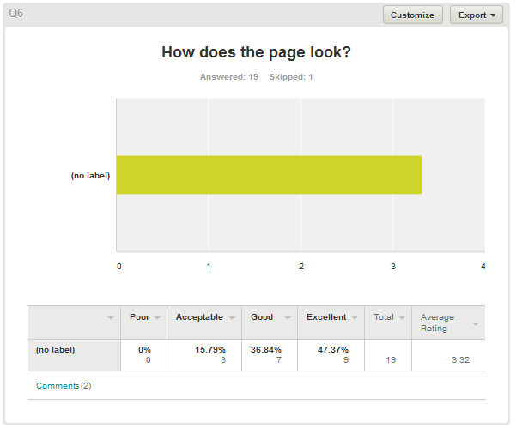

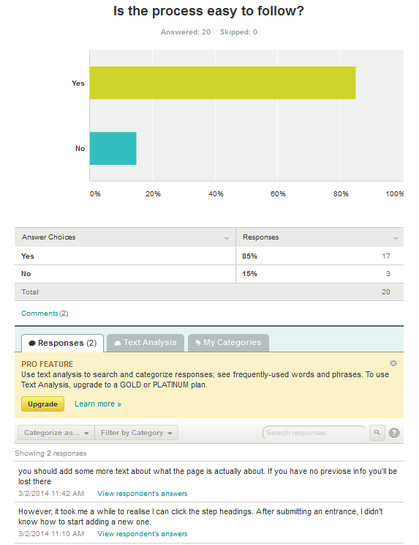

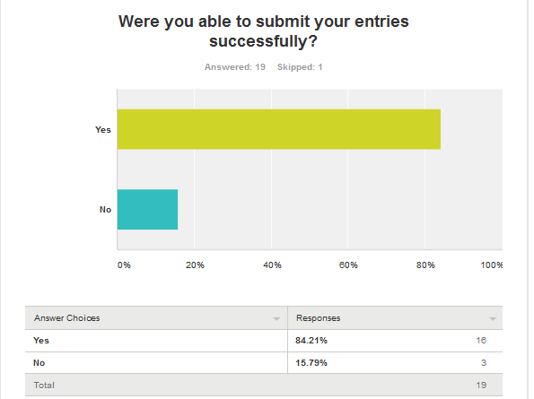

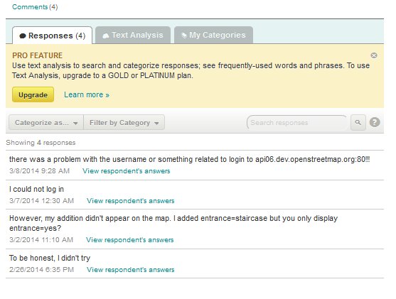

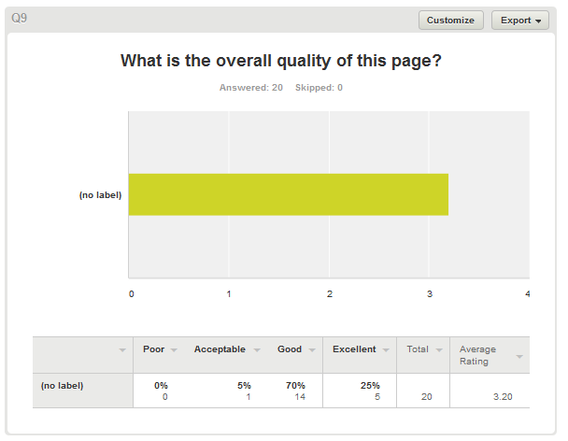

**Ideas for improvement:**

###### Showing 11 responses

Looks cool

3/10/2014

Go to my location button did not work- Purpose of the site is not specified to the visitor

3/10/2014

The second step seems to be not very essential, could be left out !

3/10/2014

Put more description on the page!

3/8/2014

Too much free space on the page. A little more explanation can surely help

3/8/2014

No improvements needed. It was easy and simple

3/7/2014

After clicking the submit button the notification is not very explicit. maybe it should be relocated or highlighted.

3/4/2014

Add more text information and tell what the page is attempting to do

3/2/2014

Display a spinner while a network operation or geolocation is ongoing, and an error message if something goes wrong. Allow existing pins to be clicked to view and edit (and drag?) them. When I have chosen the area and go to next step, automatically zoom in the map?

3/2/2014

Change the color scheme of the map. The best palette that I've ever is the one on the soviet topographic maps.

2/26/2014

Looks good

2/26/2014